School on the Computer

Kids can’t go to their classrooms right now because we don’t want to spread germs. Staying at home is the best way to stay healthy. However, we still need to learn. I am going to learn using my computer at home.
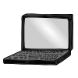
My teacher will give me work to do on my computer. I may watch a video and answer questions. I can watch a video of my teacher teaching me a lesson. Sometimes, I might talk to my teacher and kids in my class on my computer. It will be different seeing my teacher and friends on my computer. We can talk about a story or math. We might talk about the weather or science.
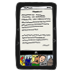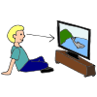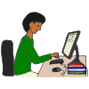
I might think this is funny or weird. I might feel uncomfortable. It will be ok. It is good for me to talk to my teacher and friends using my computer. I can do this until it is safe to go back to my school building and classroom.
